Rock Paper Scissors Code Explanation
Section One the Beginning: Imports and Constants
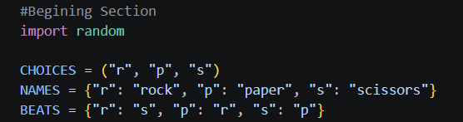
Test Cases
Expression | Result
NAMES [“paper”] | “paper”
BEATS [“s”] | “p” scissors beats paper
“x” in CHOICES | False

Pseudocode
bring in the random tools
make a fixed list of legal letters
make a lookup: letter to full name
make a lookup: letter to the letter it defeats

Remember: These three variables hold all the game’s data and rules in one place.

Section Two the First Function: get_player_choice ():
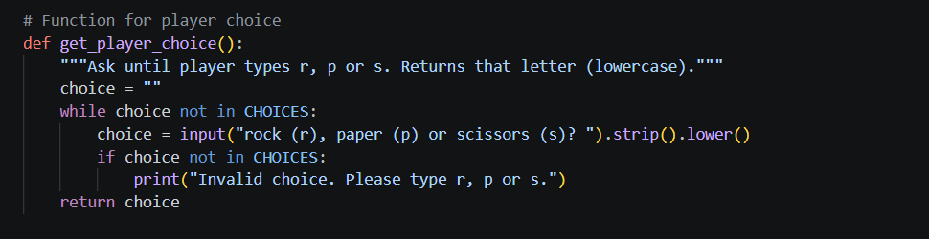

Test Cases
Player Types | What happens | Returns
r | Valid immediately | “r”
P | Spaces removed, lowercased | “p”
S | Lowercased | “s”
x then s | Error printed once, asks again | “s”
rock | Error (only single letters allowed) | asks again
(just enter) | Error | asks again

Pseudocode
set choice to empty
WHILE choice is not r, p, or s:
ask the player, clean up their input
IF it’s still not valid:
print an error
RETURN choice

Line by line
def get_player_choice(): defines the function. It takes no inputs.

choice = “” starts with an empty string. This is not in CHOICES, so the loop is guaranteed to run at least once.

While choice not in CHOICES: repeats as long as the answer is invalid

choice = input (…) shows the prompt and captures what the player types

.strip () removes spaces from both ends “ r “ becomes “r”

.lower () converts to lowercase “R” becomes “r”

if choice not in CHOICES checks the cleaned answer.

print (“Invalid choice…”) tells the player what went wrong with their input. Th loop then repeats

return choice sends the valid letter back to whoever called the function

Remember: The function won’t let the program continue until valid choice.
Section Three the second Function: number_to_letter (chossen):
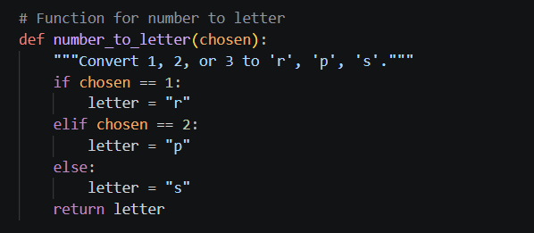
Test Cases
Input | Output
1 | “r”
2 | “p”
3 | “s”
99 (bad input) | “s” because else catches anything not 1 or 2

Pseudocode
IF number is 1 letter is r
ELIF number is 2 letter is p
ELSE letter is s
RETURN letter

Line by line
def number_to_letter(chosen): takes on parameter, a number
if chosen == 1: checks for 1. The double == means is equal to “ (a single = assigns).

letter = “r” stores rock’s letter if the check passed

elif chosen == 2: only runs if the first check failed. It checks for 2

letter = “p” stores paper’s letter

else: catches everything left over, which is 3 when used correctly.

letter = “s” stores scissor’s letter

return letter hands the result back

Remember: This function translates a number into a game choice

Section Four the third Function: get_computer_choice ()
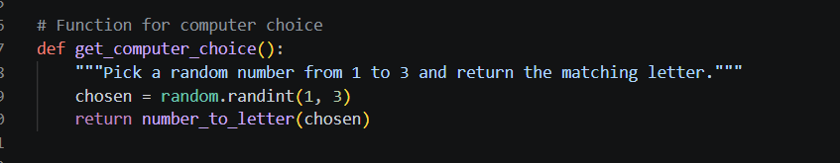

Test Cases
Check | Expected
Result is always in (“r”, “p”, “s”) | Always True
Run 300 times | All three letters should appear
Result is ever “x” or None | Never

Pseudocode
pick a random whole number from 1 to 3
convert it to a letter
RETURN the letter

Line by line
def get_computer_choice(): takes no inputs

random.randint (1,3) returns a random integer. Both ends are included so it can be 1,2,3.

Return number_letter(chosen) passes the number to the previous function and returns whatever letter comes back
Remember: The computer picks a random number, number_letter a move
Section Five the Fourth Function: determine_winner(player, computer)
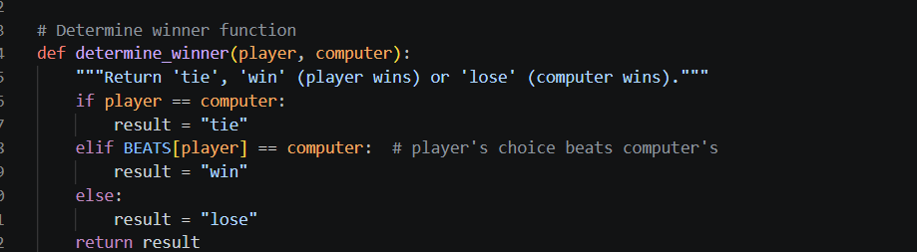
Test Cases
Player | Computer | Result | Why
r | r | tie | same
p | p | tie | same
s | s | tie | same
r | s | win | BEATS [“r”] is “s”
p | r | win | BEATS [“p”] is “r”
s | p | win | BEATS [“s”] is “p”
r | p | lose | BEATS [“r”] is “s” not p
p | s | lose | BEATS [“p”] is “r” not s
s | r | lose | BEATS [“s”] is “p” not r

Pseudocode
IF both picked the same tie
ELIF what the player’s pick beats equals the computer’s pick win
ELSE lose
RETURN result

Line by line
def determine_winner(player, computer): takes two parameters, both letters

if player == computer: identical picks mean a tie. This is checked first so the dictionary lookup never has to handle ties.

result = tie records the tie

elif BEATS [player] == computer: looks up what the player’s choice defeats. If it’s different than the computer’s choice the player wins.

result= “win” records a player win

else: is the only remaining possibility: the computer’s choice beats the player’s

result = “lose” records a loss

return result sends back one of three words tie, win, or lose

Remember: The code checks for a tie first, then uses the rules dictionary. Anything left over is a loss.

Section Six the sixth Function: result_message(result)
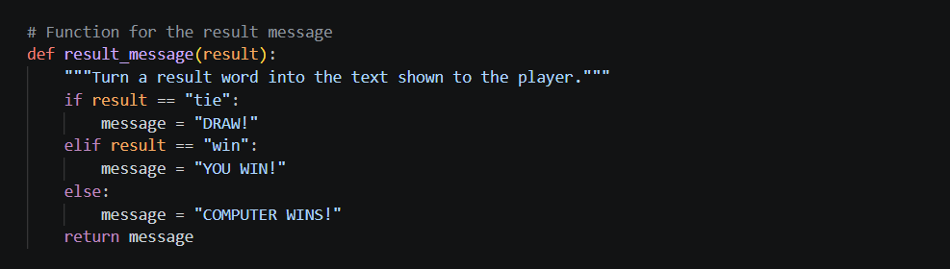
Test Cases
Input | Output
“tie” | “DRAW!”
“win” | “YOU WIN!”
“lose” | “COMPUTER WINS”

Pseudocode
IF result is tie message is DRAW!
ELIF result is win message is YOU WIN!
ELSE message is COMPUTER WINS!
RETURN Message

Line by line
def result_message(result): takes the result word form the previous function

if result == “tie”: and message = “Draw!” handle ties

elif result == “win” and message “YOU WIN!” handle player wins.

else: and message = “COMPUTER WINS!” handle losses

return message gives back the text. It doesn’t print. Printing happens in play_round, which keeps each function doing one job.

Remember: This function turns an internal result word into a friendly message

Section Seven the seventh Function: new_scoreboard()
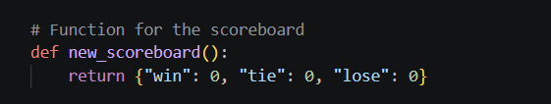
Test Cases
Check | Expected
New_scoreboard() | {“win”: 0, “tie”: 0, “lose”: 0}
Call twice, change one | The other in unaffected, since each call makes a new dictionary

Pseudocode
make a dictionary with, tie, lose all set to 0
RETURN it

Line by line
def new_scorebaord(): takes no inputs

return {“win”: 0, “tie”: 0. “lose”: 0} builds and returns a fresh dictionary. The keys (win, tie, lose) match the words determine_winner returns, which is why update_score is so simple.

Remember: The scoreboard always starts at zero in every category

Section Eight the eighth Function: update_score(score, result)
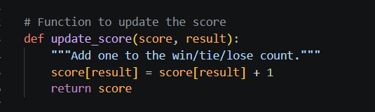
Test Cases
Starting score | Result | Ending score
{win: 0  tie: 0  lose:0} | “win” | {win: 1, tie: 0, lose: 0}
{win: 1  tie: 0  lose:0} | “tie” | {win: 1, tie: 1, lose: 0}
{win: 0  tie: 1  lose:0} | “lose” | {win: 1, tie: 1, lose: 1}
any | “banana” | KeyError but this can’t happen because determine_winner only returns the three valid words
Pseudocode
Find the count matching the result
add 1 to it
RETURN the scoreboard

Line by line
def update_score(score, result): takes the scoreboard dictionary and the result word

score[result] = score [result] + 1 reads the current count, adds 1, and stores it back. If result is “win” this changes score [win].

return score returns the dictionary. The dictionary is also change in place, so play_round doesn’t even need the return value

Remember: Every game adda exactly one to exactly one score

Section Nine the ninth Function: win_percentage(score)
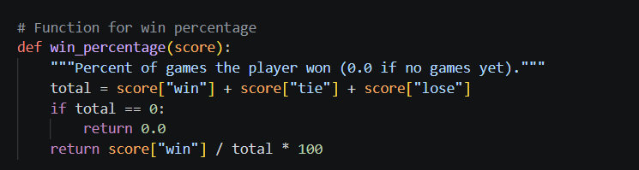
Test Cases
Score | Result
Win 0, tie 0, lose 0 | 0.0
Win 1, tie 0, lose 0 | 100.0
Win 2, tie 1, lose 1 | 50.0
Win 1, tie 1, lose 1 | 33.33
Win 0, tie 2, lose 3 | 0.0

Pseudocode
total= wins+ ties + losses
IF total is 0:
RETURN 0
RETURN wins/total * 100

Line by line
def win_percentage(score): takes the scoreboard
total= adds all three counts to get the number of games played
if total == 0 guards against dividing by zero which would crash Python
return 0.0 exits early with o when no games have been played
return score[“win”]/ total * 100 divides wins by total,, giving a decimal like 0.5 then multiplies by 100 to get a percentage

Remember: Wins divided by total games time 100. Always check for zero games first.

Section ten the tenth Function: display_score(score)
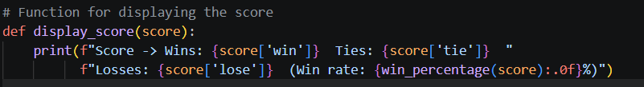
Test Cases
Score | Printed Output
Win 0, tie 0, lose 0 | Score Wins: 0 Ties:0 Losses:0 Win rate:05
Win 2, tie 1, lose 1 | Score Wins: 2 Ties:1 Losses:1 Win rate: 50%
Win 1, tie 1, lose 1 | … WIN RATE 33%

Pseudocode
Print the wins, ties, losses
Print the win percentage rounded to a whole number

Line by line
def display_score(score) takes the scoreboard
print (f”..”) prints text. The f before the quote makes it an f-string where anything in {} is replaced with it’s value
{score[‘win”…} inserts the three counts. Single quotes inside avoid clashing with the outer double quotes
The second line continues the string. Python joins two adjacent strings automatically so the line break is only for readability
{win_perecnetage(score): . Of calls the percentage function and formats it with .OF meaning zero decimal places

Remember: This function only displays. It changes nothing

Section eleven the elvenlth Function: ask_play_again()
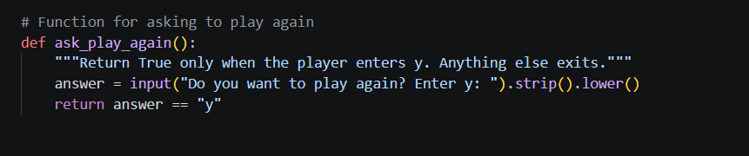

Test Cases
Score | Printed Output
y | T
Y | T
y | T
n | F
yes | F
Just enter | F

Pseudocode
Ask the player, clean up their answer
RETURN true is the answer is y, otherwise false

Line by line
def ask_play_again(): takes not inputs
answer= input (…) ,strip(). Lower() asks the question, removes extra spaces, and lowercases the reply.
Return answer == “y” is a comparison and a comparison proeudces a Boolean. The function returns that dircelty.

Section twelve the twelve Function: play_round(score)
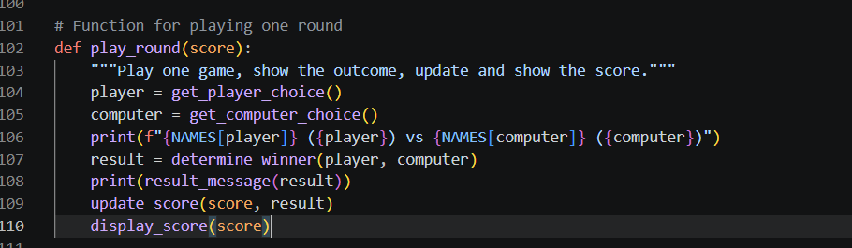

Test Cases
Player | Computer | Output lines
p | p | Paper v paer/DRAW!/Ties go up by 1
s | r | S v rock/Computer win/ losess goes up by 1

Pseudocode
player = aks the player for a move
computer = get random computer move
print both moves with full names
result = compare them
print the result message
add the result to the scoreboard
print the scoreboard

Line by line
def play_round(score): takes the scoreboard so it can be updated.
player = get_player_choice() runs function #2 and stores the letter.
computer = get_computer_choice() runs function #4 and stores the letter.
print(f"{NAMES[player]} ({player}) vs ...") looks up each full name and shows both moves, like rock (r) vs scissors (s).
result = determine_winner(player, computer) runs function #5.
print(result_message(result)) converts the result to text (function #6) and prints it.
update_score(score, result) adds one to the right counter (function #8).
display_score(score) prints the new totals (function #10).

Remember: This function calls the other functions in order to play one complete round

Section thirteen the thirteenth Function: main()
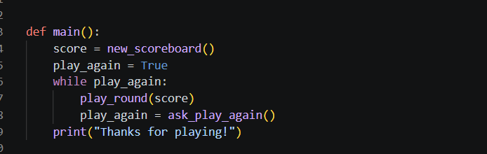

Test Cases
Step | Input | Result
Round 1 | r | Round plays, score updates
Ask again | y | Flag stays True, loops
Round 2 | p | Round plays, score acclimates
Ask again | n | Flag becomes False, loop ends
End |  | Thanks for playing!

Edge case: is player types n right after round1, exactly one round is played

Pseudocode
score= fresh scoreboard
play_again = true
WHILE play_again is true:
play one round
play_again = ask if they want another
print thank-you message
Line by line
def main(): defines the controlling function.
score = new_scoreboard() creates the zeroed scoreboard once, so it persists across rounds.
play_again = True is a Boolean flag that makes the loop start.
while play_again: keeps looping while the flag is True.
play_round(score) plays one full game.
play_again = ask_play_again() updates the flag with True or False.
print("Thanks for playing!") is not indented, so it runs only after the loop ends.

Remember: main create the score, repeats rounds until the player stops, then says goodbye.

Section fourteen the fourteenth Staring the program
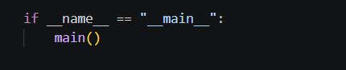
Test cases
How the file is used | Does the game start?
Run python rps.py | Yes
Another file does imprt rps | No so the fucniton can be reused or test without launching the game

Pseudocode
If this file is being run directly:
Start main

Line by line
if __name__ == "__main__": is a special check. When you run the file directly, Python sets __name__ to "__main__".
main() starts the game.


